Chapter 17, Problem 15.

Express the Fourier series

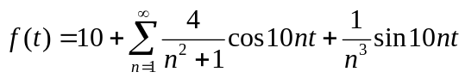

- in a cosine and angle form,
- in a sine and angle form.

